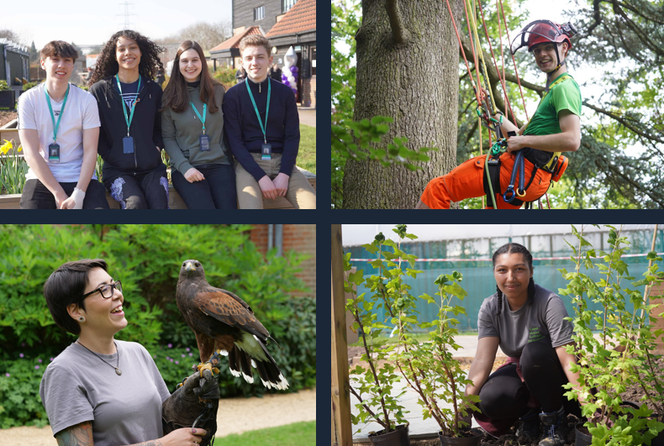

Lecturer in English

Job Description & Person Specification

capel.ac.uk

capel.ac.uk

Why Capel Manor College?

capel.ac.uk

A note from the Principal

capel.ac.uk

capel.ac.uk

For further information please contact our HR team.

capel.ac.uk

**JOB DESCRIPTION & PERSON SPECIFICATION**

**JOB DESCRIPTION**

**Post**  Lecturer in English

**Scale**  Lecturing

**Grade** Scale 19-35

**Responsible to** Team Leader for English

**Location** Enfield

**Contract** Full-time, Permanent

**Key Responsibilities:**

The lecturer in English will be responsible for teaching and assessing English subjects, conducting student tutorials, providing specialised advice, supporting curriculum development. The role also involves contributing to the development of new courses, modules, and activities, and fulfilling additional duties as directed by the Director of English and Maths.

**Responsibilities:**

1. Prepare lessons, creating engaging learning materials for students
2. Deliver stimulating GCSE English lessons to students
3. Assess and evaluate learner progress and provide additional support to those learners who are behind with progress
4. Participate in the development, organisation and delivery of new educational activities
5. Contribute to the assessment process
6. Prepare reports and statistics as required to contribute to the College’s quality assurance and exam process
7. Assist with the coordination of Learning Support activities when required
8. Participate in internal and external verification procedures
9. Conduct examination duties, ensuring assessments meet standards
10. Work with course teams to improve the curriculum, attending team meetings to stay informed about progress
11. Commit to personal growth and offer advice on English and Maths education
12. Assist in promotions, open weekend activities and other exhibitions
13. Engage with students during enrolment, advice sessions, and review meetings
14. Manage budgets and conduct research for course materials
15. Liaise with external bodies, speakers, and representatives
16. Maintain discipline, and handle other student-related duties as requested

**General Responsibilities:**

1. Promote and implement all College policies, particularly those which refer to health & safety, equality of opportunity and Safeguarding young people and vulnerable adults
2. Participate in College programmes of staff appraisal and continuing professional development
3. Develop effective working relationships internally and with external partners
4. To operate at all times in line with the College’s values and behaviours
5. Undertake other duties as may reasonably be required in the interests of the efficient functioning of the College

**PERSON SPECIFICATION**

**Qualifications**

* Possess a Level 2 qualification in Maths or a willingness to achieve within a specified period
* Possess Level 4-9 (A*-C) GCSE in English
* Evidence of continuous professional development
* Relevant degree, or professional accreditation, HND or equivalent desirable, although not essential
* Teaching qualification or willingness to achieve (support will be given to gain accreditation over a specified period)

**Experience**

* Some experience of working in an educational or training environment would be desirable
* Experience of working with 16-18 year olds, young adults and adult learners would be desirable
* Experience of teaching GCSE, particularly English would be desirable
* Experience of managing a pressurised and demanding role
* Administrative experience

**Skills, Abilities and Knowledge**

* A passion for English language
* The ability to develop intellectual curiosity and create a love of learning
* Excellent verbal and written communication skills
* Excellent administrative skills
* Excellent organisational skills
* Evidence of effective team working
* The ability to develop positive working relationships with individuals at all levels
* Experience in being adaptable in working in different working environments and teams.
* The ability to work on own initiative and as part of a team
* Enthusiasm for working with students of all abilities
* Familiarity with Information Learning Technology applications is desirable
* A high level of ICT skills to operate tracking and management systems effectively

**Other Factors**

* An understanding of and commitment to safeguarding young people and vulnerable adults
* Ability to form and maintain appropriate relationships and personal boundaries with children and young people/vulnerable adults
* Emotional resilience
* The ability and determination to promote equality, diversity and inclusion throughout all aspects of College life, including employment and service delivery
* Should the position involve regular driving, a clean driving licence is required