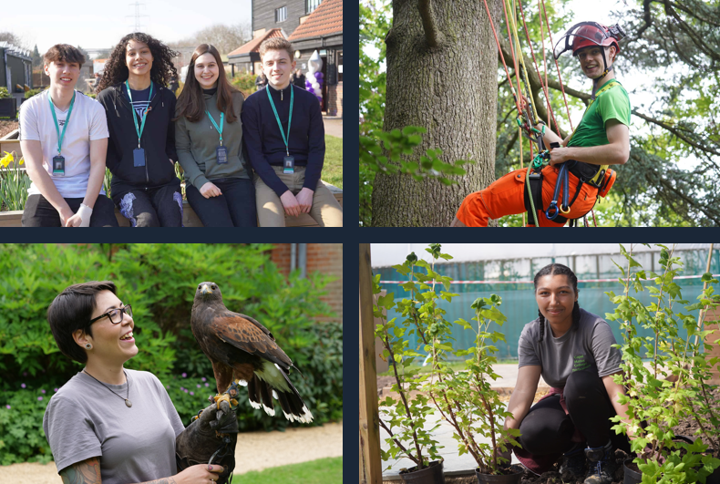

Learning Support Assistant

Job Description & Person Specification
capel.ac.uk

capel.ac.uk
Why Capel Manor College?
capel.ac.uk
capel.ac.uk
capel.ac.uk
For further information please contact our HR team.
capel.ac.uk

JOB DESCRIPTION & PERSON SPECIFICATION

JOB DESCRIPTION

Post Learning Support Assistant
Scale Business and Learning Support
Grade Scale 4
Responsible to Learning Support Manager
Location Enfield/Gunnersbury Park/Crystal Palace/Mottingham/Regents Park/Cross College
Contract Full-time/Part-time, Fixed-term/Permanent, Term time only

Key Responsibilities:

The key responsibility of the Learning Support Assistant is to provide learning support to students with learning difficulties and/or disabilities on an individual and small group basis in both practical and theory lessons. They will be responsible for tailoring a programme of learning support to individual students based upon their individual needs. They will liaise with the course and support teams to ensure that the individual learning needs of students with learning difficulties and/or disabilities are met.

Responsibilities:

- To assist in delivering vocational programmes and individual learning programmes to students with a variety of learning needs.
- To assist teaching staff, with groups of students with learning difficulties and/or disabilities or behavioural and emotional needs both in the classroom and other activities.
- To support students with different learning needs in their everyday college life.
- Support the inclusion and achievement of students
- Establish constructive relationships with students and interact with them according to their specific needs.
- Promote self-esteem and independence.
- Assist with the development and implementation of individual education or behaviour support plans
- Encourage students to interact with others and engage in activities led by the class Lecturer.
- Use strategies, in liaison with teaching staff, to support student achievement
- Provide detailed and regular feedback on student progress.
- Promote good student behaviour, dealing promptly with conflict and incidents.
- Administer routine tests and help with examination support when required.
- Assist in supervising break times for students when required.
- To liaise with learning Support Tutors and personal tutors regarding any difficulties that students may present.
- To attend the School of Learning Support or other team meetings on a regular basis.
- To produce accurate records of learning support activities in line with Additional Learning Support procedures.
- To be responsible for ensuring the health and safety of students is maintained at all times during the training sessions.
- To take part and support students on summer schools outside of term time and attend parents evening when appropriate.

General Responsibilities:

- Promote and implement all College policies, particularly those which refer to health & safety, equality of opportunity and Safeguarding young people and vulnerable adults
- Participate in College programmes of staff appraisal and continuing professional development
- Develop effective working relationships internally and with external partners
- To operate at all times in line with the College’s values and behaviours
- Undertake other duties as may reasonably be required in the interests of the efficient functioning of the College

PERSON SPECIFICATION

Qualifications

- Possess a Level 2 qualification/GCSE Grade C in English and Maths (or equivalent) or a willingness to achieve within a specified period of 18-24 months
- Level 2 Certificate in SpLD or willingness to achieve within a specified period of 18-24 months
- Evidence of continuous professional development

Experience

- Some experience working with young adults would be advantageous
- Experience of working in an educational setting and supporting students with Special Educational Needs (SEN) and Additional Learning Needs (ALN) would be beneficial

Skills, Abilities and Knowledge

- Knowledge and understanding of The SEND Code of Practice and Education and Health Care Plans would be advantageous
- The ability to demonstrate active listening skills and have strong verbal communication skills
- The ability to communicate effectively orally and in writing
- A dedication to establishing positive relationships with students and understanding their needs
- A willingness to adapt to a wide range of duties within changing circumstances
- Ability to work effectively as part of a team, supporting others as required
- Excellent administrative and organisational skills
- Working knowledge of Microsoft programs, including Word, Excel, Teams or a willingness to learn.

Other Factors

- An understanding of and commitment to safeguarding young people and vulnerable adults
- Ability to form and maintain appropriate relationships and personal boundaries with children and young people/vulnerable adults
- Emotional resilience
- Be able to work flexibly and respond efficiently to the needs of the service
- The ability and determination to promote equality, diversity and inclusion throughout all aspects of College life, including employment and service delivery
- Should the position involve regular driving, a clean driving licence is required

